**Lecture Note: Numerical Analysis (17) ODE Applications**

1. **1-D Ground Vehicle Problem: Dynamics and Control**
   1. Problem statement: Car motion along the load with hills and valleys using a point-mass model

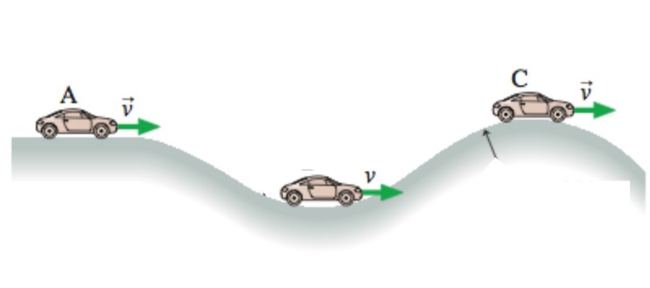 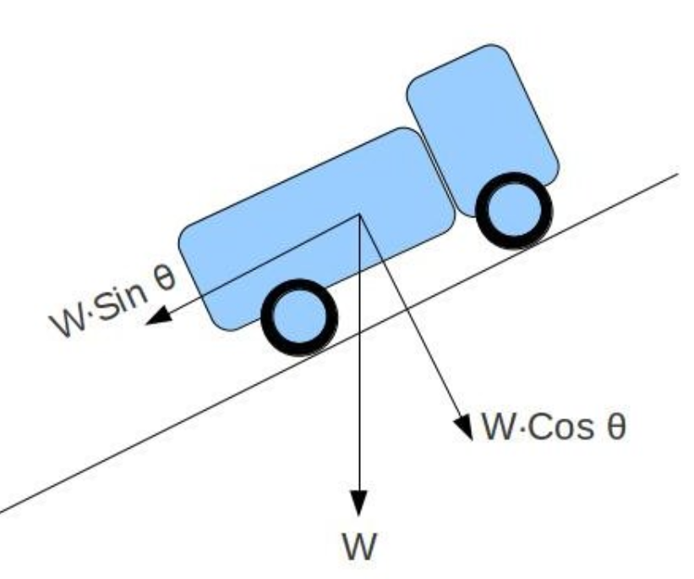



where



: mass (=1500 kg)

: x-position

: gravity constant (=9.8)

: climb angle

: friction force (from bearings, not from the static friction between the wheel and ground

: drag coefficient (= 0.45)

: air density (=1.2250 kg/m3)

: reference area of the car (=1.0 m2)

: thrust input. Actually, it comes from the static friction force between the wheel and ground.

The required torque is supply by the engine through the transmission.

* 1. Prediction of the steady motion: Required thrust at a prescribed speed and climb angle

Motion equation at a constant speed 



Therefore, we can compute the required thrust with the prescribed speed and climb angle

1. Plot T at  over the range of speed variation from  km/hr to  km/hr
2. Repeat at  degrees
3. Repeat at  degrees
4. Repeat at  degrees
5. Repeat at  degrees
   1. Simulation with the prescribed thrust condition over  sec

Direction1: Set the trust  as the required thrust at the  km/hr and  degrees.

Direction2: Set the initial speed as 60 km/hr

Direction 3: Use the load configuration shown below

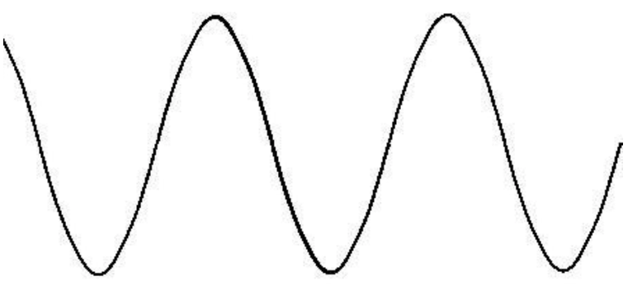

 in degrees

* 1. Design of Speed controller: Evaluate the controller performance through the simulation over  sec

Direction 1: reference x-position with  in m

Direction 2: reference speed with  in m/sec

Direction 3: Set the trust  as the required thrust at the  km/hr and  degrees.

Direction 4: Set the initial speed as 60 km/hr

Direction 5: Use the load configuration shown below

Direction 6: Use the following PD controller for the thrust with varying controller gains 



Where  is the initial thrust computed in the Direction 3

Try the initial gains with 

Direction 6: Adjust the controller gains  to improve the speed-control performance.